**Model Analysis**

**Dataset Format:=**

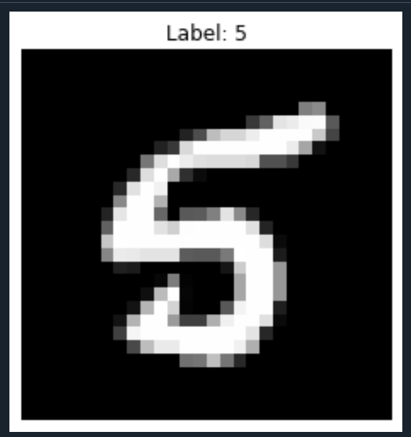

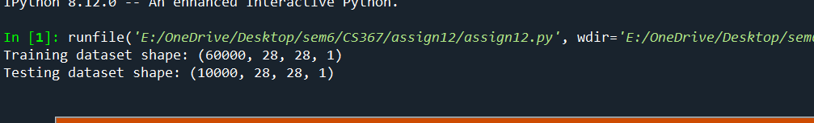

**Baseline Model:=**

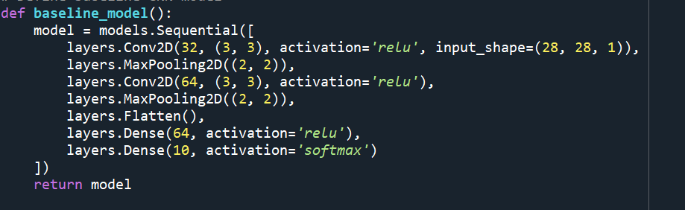

Training Phase graph of baseline model:=

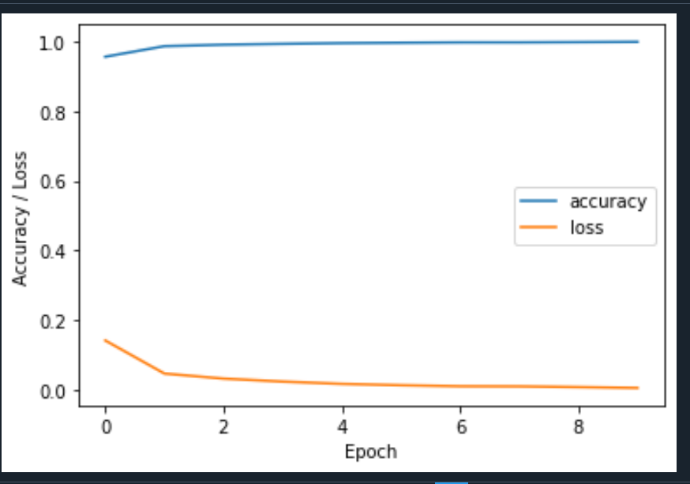

Confusion Matrix of baseline model:=

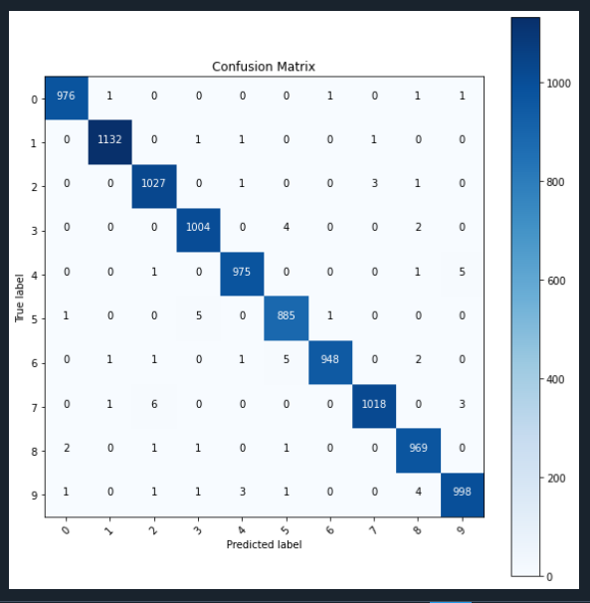

Accuracy for baseline model:=

Test accuracy: 0.9868000149726868

**Baseline Model Architecture:=**

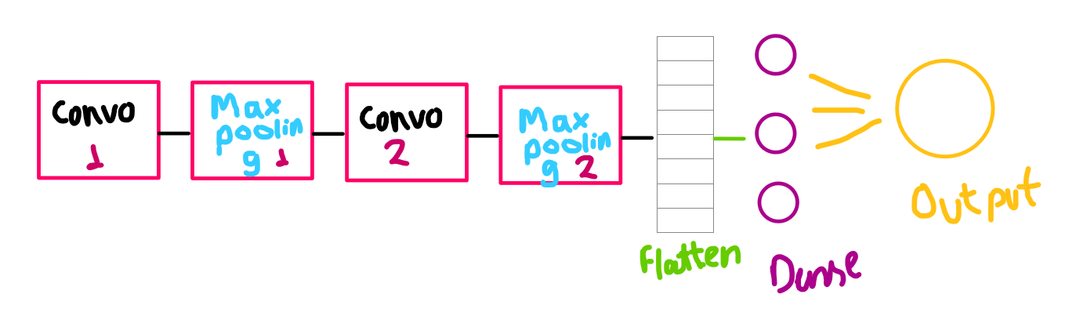

**Improved Model:=**

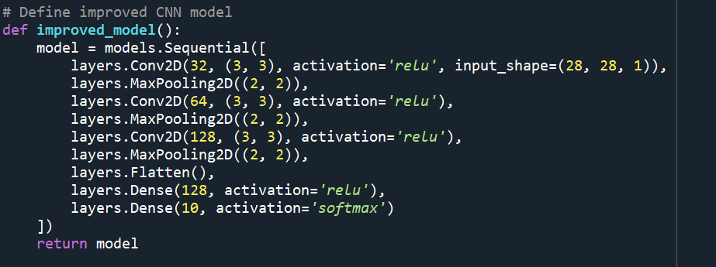

Training Phase graph of improved model:=

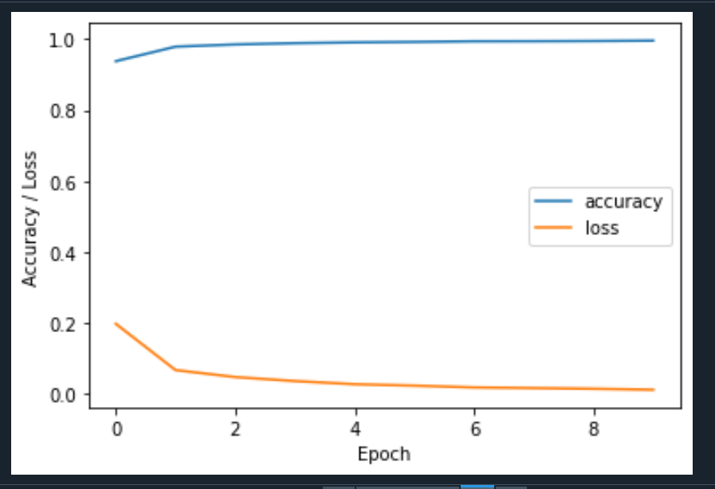

Confusion Matrix of improved model:=

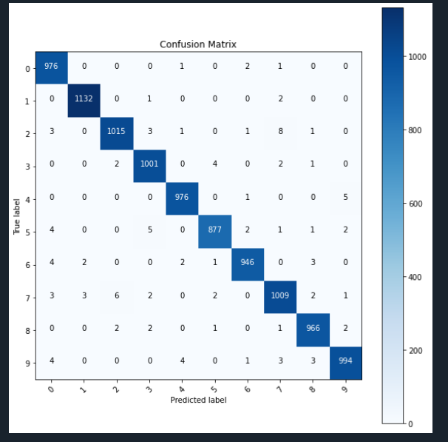

Accuracy for improved model:=

Test accuracy: 0.9908000230789185

**Improved Model Architecture:=**

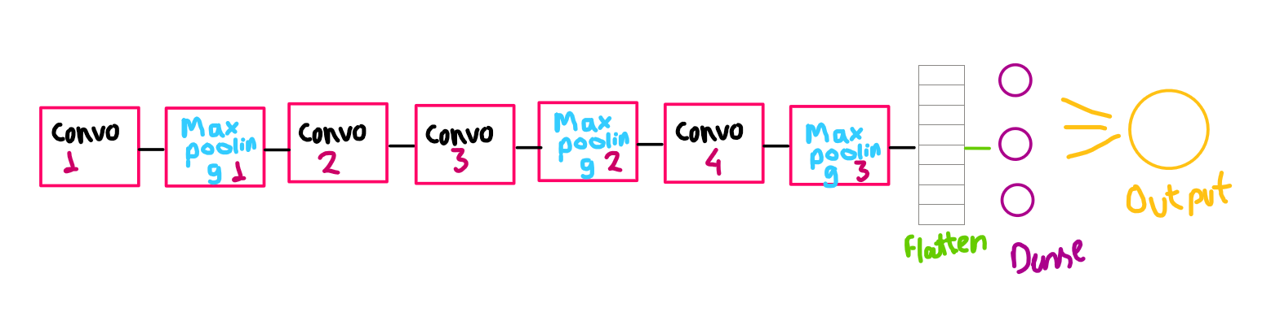

**Misclassification Examples:=**

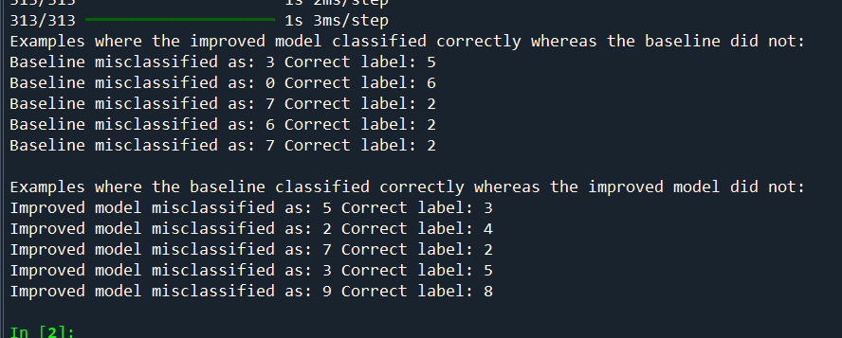

**Activation Functions Used :=**

**i)ReLU**

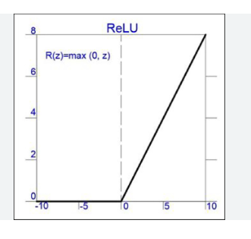

**ii) Softmax**

